GRACE PERIOD REGISTRATION

You must have Two (2) forms of identification,
One (1) with your current DeKalb County address.

Acceptable Forms of Identification, (but is not limited to):

Driver’s License | Medicare Card/Public Aid Card
State I.D. | Mortgage or Lease
Bank Statement | Passport
Birth Certificate | Payroll Check
Car Registration | Piece of mail dated within the last 30 days
Credit/Debit Card | Pre-printed Check
Employee I.D. | School I.D. Card
Firearm Owner’s Card | Social Security Card
Library Card | Utility Bill, dated within the last 30 days

- You may use your phone for a Utility Bill or Bank Statement if you are able to show the image.
- If everything is CURRENT on your Illinois Driver’s License/Illinois State I.D. your 2nd form of I.D. just needs to have your name imprinted on it.
- If you have an out of state Driver’s License/State I.D. you will need to provide the last Four (4) digits of your Social Security Number.
- All Out of County and Out of State Registrations are considered
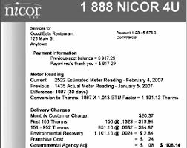
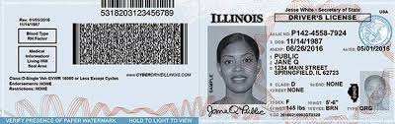
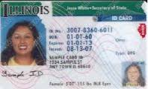
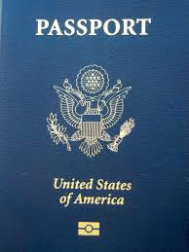
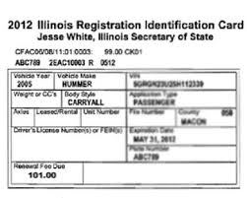
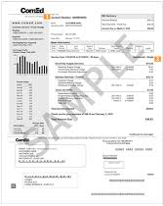
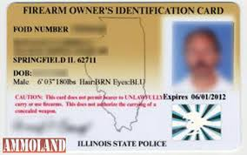
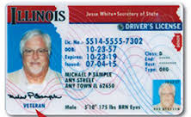
NEW REGISTRATIONS, they are not changes of address.

